**Lab 9**

**LAB STATEMENT 1**

**Question NUMBER 1**

Tcp Source port=1161

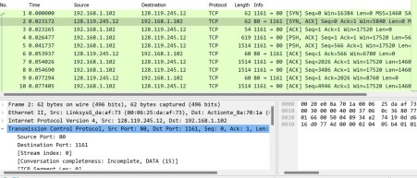

QUESTION 2



Question no 3

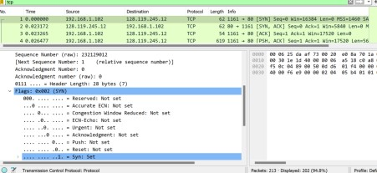

Question 4

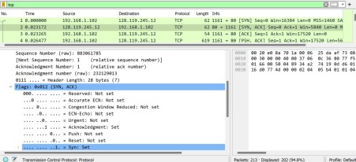

**Question 5:** In packet 9, **Ack = 2026** and **Seq = 1**. Explain these values? Client acknowledges and shows that 2025 segments have been successfully received in 1st sequence of data transfer.

**Question 6:** In packet 16, **Ack = 7866** and **Seq = 1**. Explain these values? Client acknowledges and shows that up to 7865 segments have been successfully

received in sequence number 1 of data transfer

**Question 7:** Why Wireshark uses relative sequence and ack?

It uses relative sequence numbers for improvement of readability and usability. This makes numbers easier to read and compare for catching up errors and network anomalies

**LAB STATEMENT 2**

**Question 1**

# **4, source, dest,length,checksum**

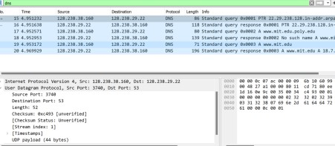

# Question 2

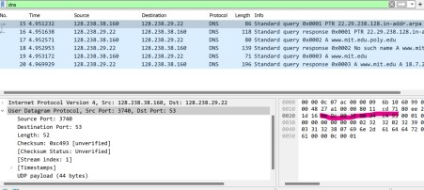

# Question no 3

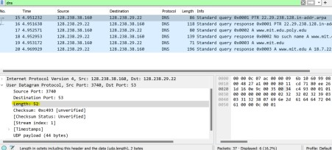

**Length is 52 8 of the header and else 44 bytes are encapsulated data from network layer**

**Question no 4**

# 53

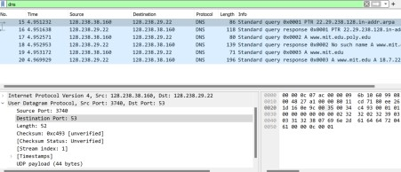

SERVER

#include <stdio.h>

#include <string.h>

#include <sys/socket.h> //socket

#include <arpa/inet.h> //inet_addr #include <pthread.h>

int opentimes=0; void *client_handler(void *arg) {

int client_sock = *((int*)arg);

char buffer[1024];

int bytes_received;

char checkbuffer[1024];

strcpy(checkbuffer, "DISCONNECT");

printf("OPEN times %d\n",opentimes);

opentimes++;

while (1) {

bytes_received = recv(client_sock, buffer, sizeof(buffer), 0);

if (strcmp(buffer,checkbuffer)==0) {

printf("Client disconnected\n");

close(client_sock);

break;

}

buffer[bytes_received] = '\0';

//strcat(buffer," :Server Response\0");

send(client_sock, buffer, bytes_received, 0);

}

close(client_sock);

pthread_exit(NULL);

}

int main(void)

{

int socket_desc, client_sock, client_size;

struct sockaddr_in server_addr, client_addr; //SERVER ADDR will have all the

server address

char server_message[2000], client_message[2000]; // Sending values from the

server and receive from the server we need this

pthread_t threads[3];

//Cleaning the Buffers

memset(server_message,'\0',sizeof(server_message));

memset(client_message,'\0',sizeof(client_message)); // Set all bits of the padding

field//

//Creating Socket

socket_desc = socket(AF_INET, SOCK_STREAM, 0);

if(socket_desc < 0)

{

printf("Could Not Create Socket. Error!!!!!\n");

return -1;

}

printf("Socket Created\n");

//Binding IP and Port to socket

server_addr.sin_family = AF_INET; /* Address family = Internet */

server_addr.sin_port = htons(3000); // Set port number, using htons function to

use proper byte order */

server_addr.sin_addr.s_addr = inet_addr("127.0.0.1"); /* Set IP address to localhost */

// BINDING FUNCTION

if(bind(socket_desc, (struct sockaddr*)&server_addr, sizeof(server_addr))<0)

{

printf("Bind Failed. Error!!!!!\n");

return -1;

}

printf("Bind Done\n");

//Put the socket into Listening State

int index_thread=0;

if(listen(socket_desc, 1) < 0)

{

printf("Listening Failed. Error!!!!!\n");

return -1;

}

printf("Listening for Incoming Connections.....\n");

//Accept the incoming Connections

client_size = sizeof(client_addr);

int index=0;

while(index<4){

client_sock = accept(socket_desc, (struct sockaddr*)&client_addr, &client_size);

// heree particular client k liye new socket create kr rhaa ha

if (client_sock < 0)

{

printf("Accept Failed. Error!!!!!!\n");

return -1;

}

printf("Client Connected with IP: %s and Port No: %i\n",

inet_ntoa(client_addr.sin_addr), ntohs(client_addr.sin_port));

if (pthread_create(&threads[index], NULL, client_handler, &client_sock) != 0) {

perror("Thread creation failed");

continue;

}

index++;

}

memset(server_message,'\0',sizeof(server_message));

memset(client_message,'\0',sizeof(client_message));

//Closing the Socket

close(client_sock);

close(socket_desc);

return 0;

## CLIENT

**#include <stdio.h>**

**#include <string.h>**

**#include <sys/socket.h> #include <arpa/inet.h> int main() {**

**int socket_desc;**

**struct sockaddr_in server_addr;**

**char server_message[2000], client_message[2000]; memset(server_message, '\0', sizeof(server_message));**

**memset(client_message, '\0', sizeof(client_message));**

**socket_desc = socket(AF_INET, SOCK_STREAM, 0); printf("Socket Created\n"); server_addr.sin_family = AF_INET;**

**server_addr.sin_port = htons(3000);**

**server_addr.sin_addr.s_addr = inet_addr("127.0.0.1");**

**if (connect(socket_desc, (struct sockaddr *)&server_addr,**

**sizeof(server_addr)) == -1)**

**{**

**printf("Connection Failed. Error!!!!!\n");**

**return -1;**

**}**

**printf("Connected\n");**

**while (1)**

**{**

**// Get input from the user**

**printf("Enter Message (or 'DISCONNECT' to exit): ");**

**fgets(client_message, sizeof(client_message), stdin);**

**// Send the message to the server**

**if (send(socket_desc, client_message, strlen(client_message), 0) ==-1)**

**{**

**printf("Send Failed. Error!!!!\n");**

**return -1;**

**}**

**if (strcmp(client_message, "DISCONNECT\n") == 0)**

**{**

**printf("Disconnecting from the server\n");**

**break;**

**}**

**// Receive the message back from the server**

**if (recv(socket_desc, server_message, sizeof(server_message), 0) < 0)**

**{**

**printf("Receive Failed. Error!!!!!\n");**

**return -1;**

**}**

**printf("Server Response: %s\n", server_message); memset(server_message, '\0', sizeof(server_message));**

**memset(client_message, '\0', sizeof(client_message));**

**}**

**// Closing the socket**

**close(socket_desc);**

**return 0;**

**}**

